Bacani, Micah Angelo R. 2018 – 01602

Activity 3

1. 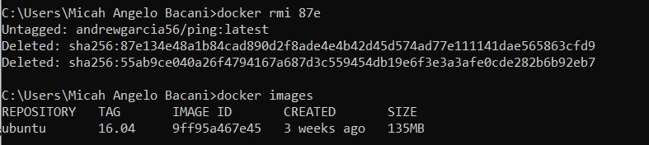Remove previous image created
2. 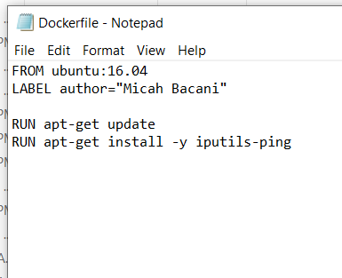Creating Dockerfile
3. 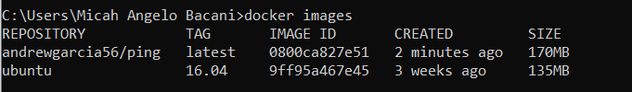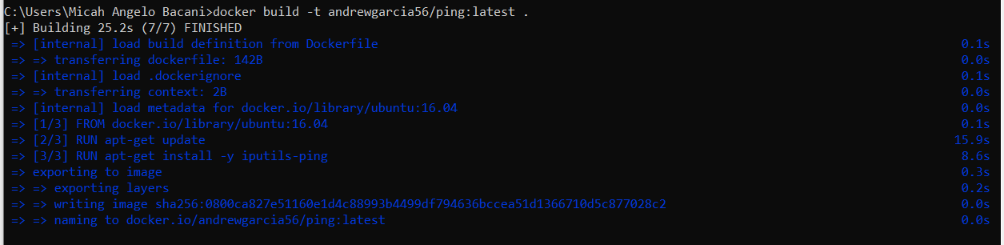Building Dockerfile
4. 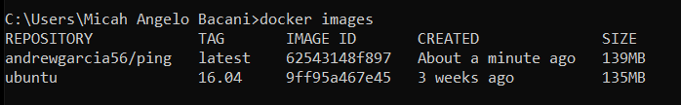Optimized docker build
5. 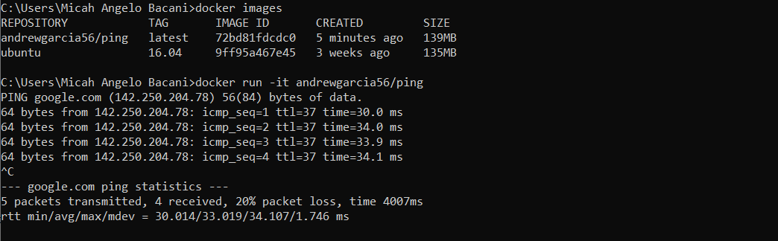Other Dockerfile directives

Note: Final Dockerfile

